Creating AWS Lambda Function to Shutdown EC2 Instance

Launch EC2
Copy the Instance ID (i-070cf25906d259f4a)

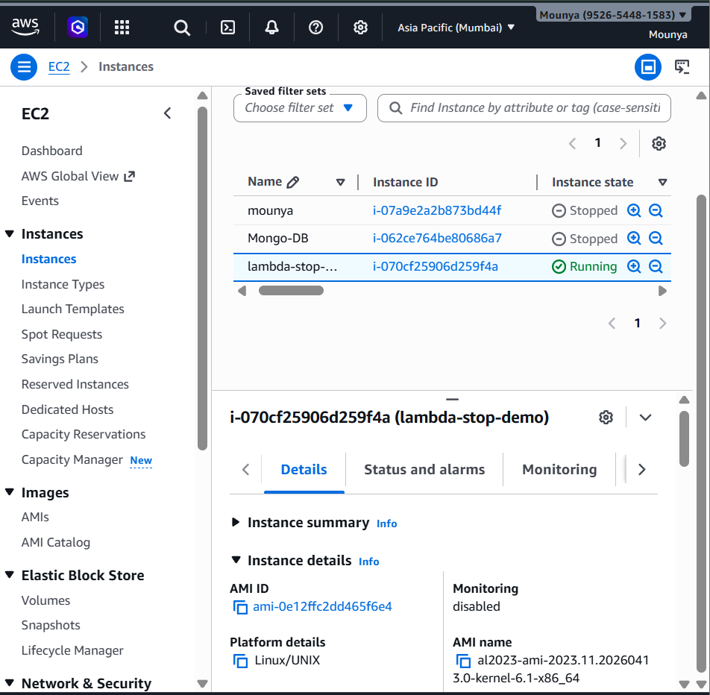
Create IAM Role
- Go to IAM
- Click Roles
- Click Create role
- Trusted entity: AWS service
- Service: Lambda
- Click Next

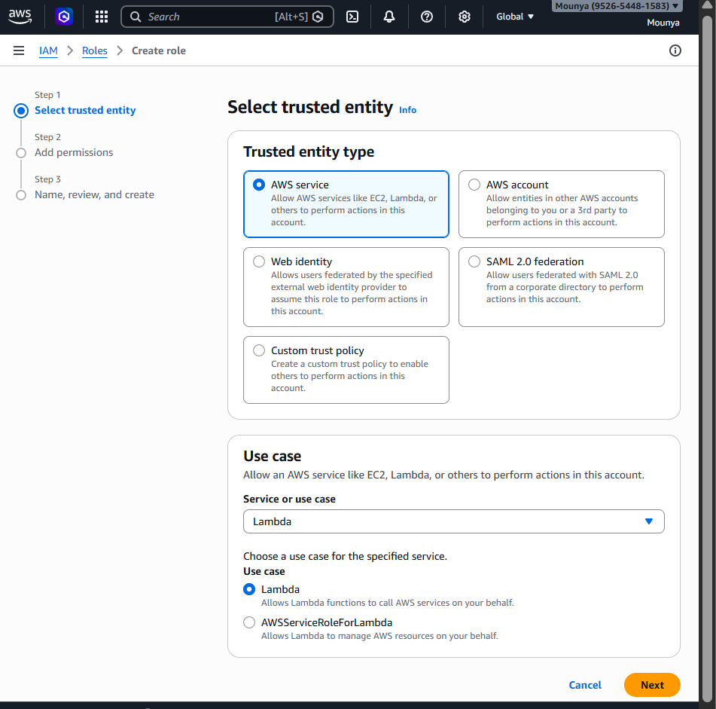

Add permissions, you will:
- ✅ Search for AmazonEC2FullAccess
- ✅ Select the checkbox
- ✅ Search for CloudWatchLogsFullAccess
- ✅ Select the checkbox
- ✅ Attach BOTH policies together
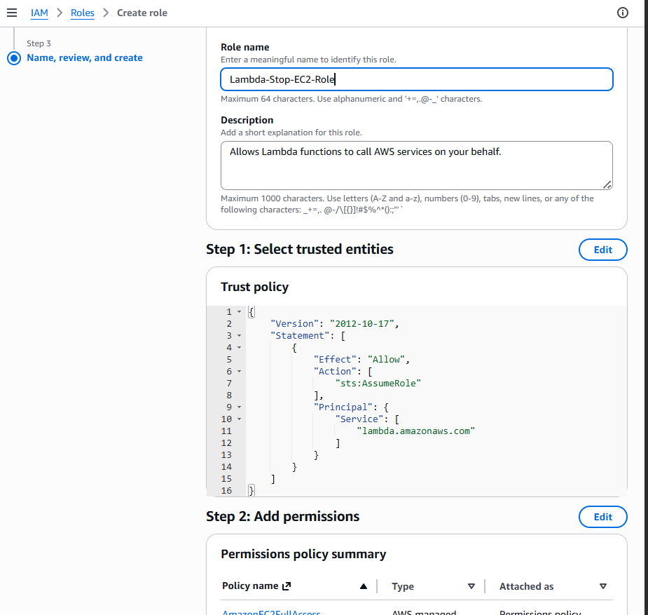

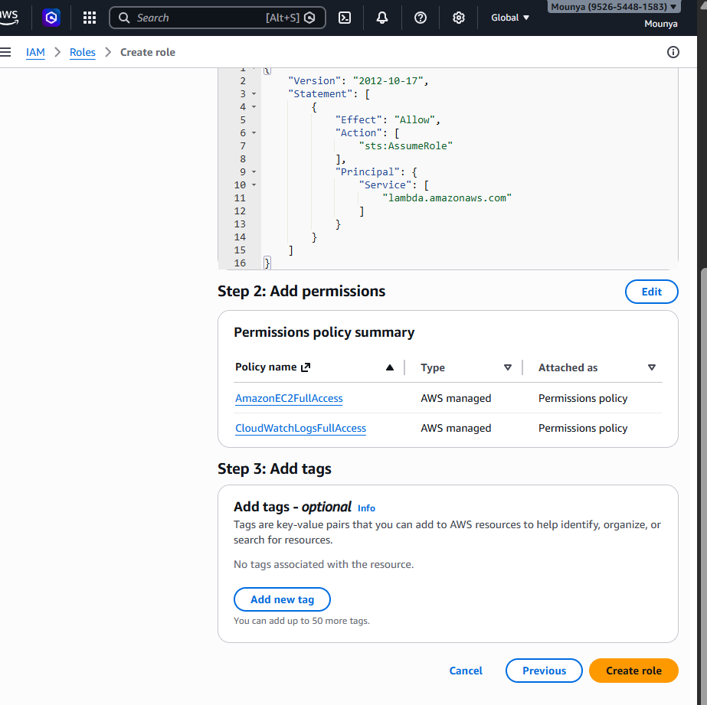

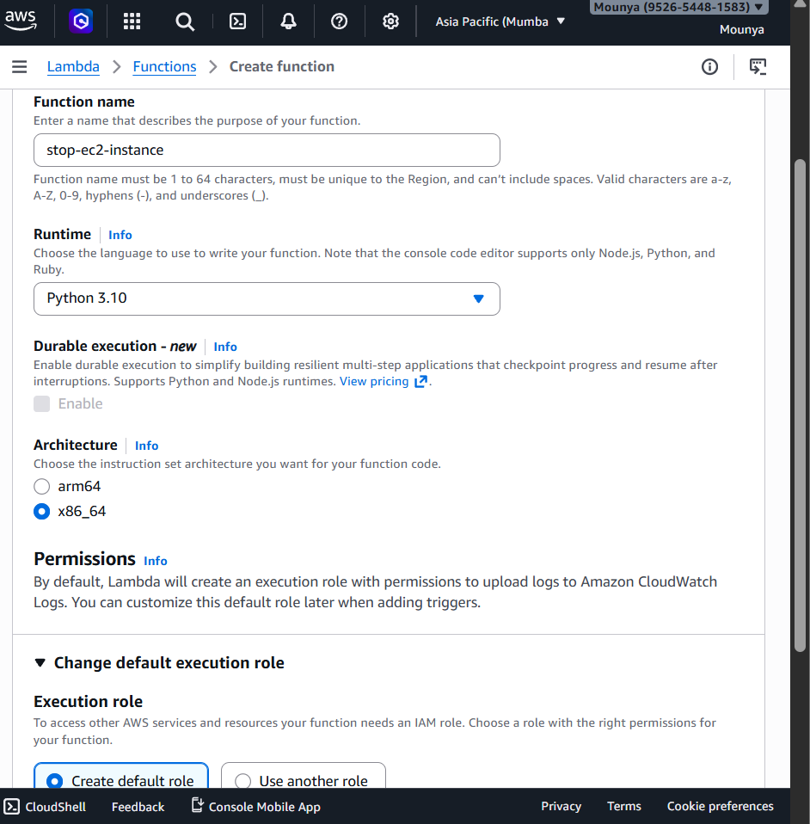

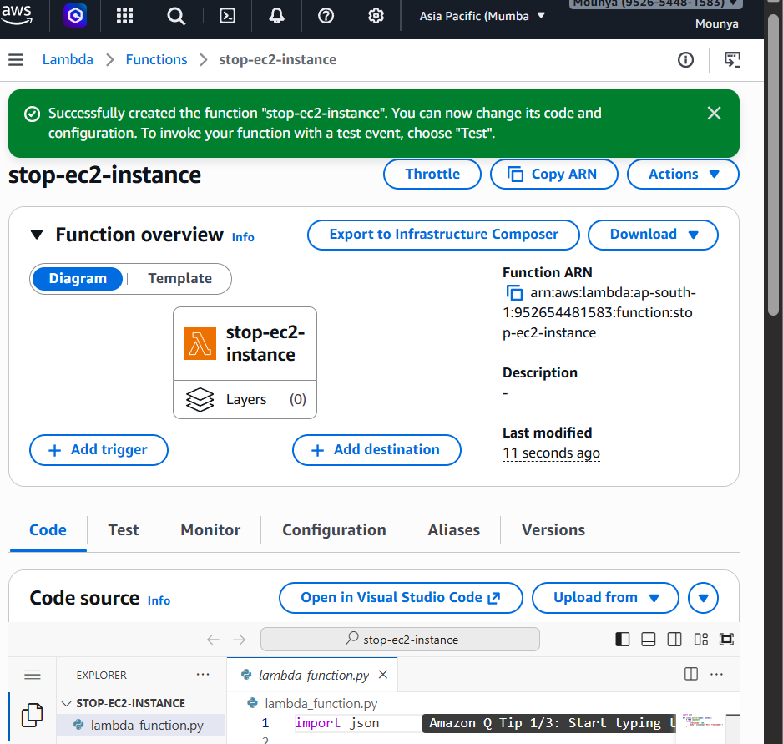

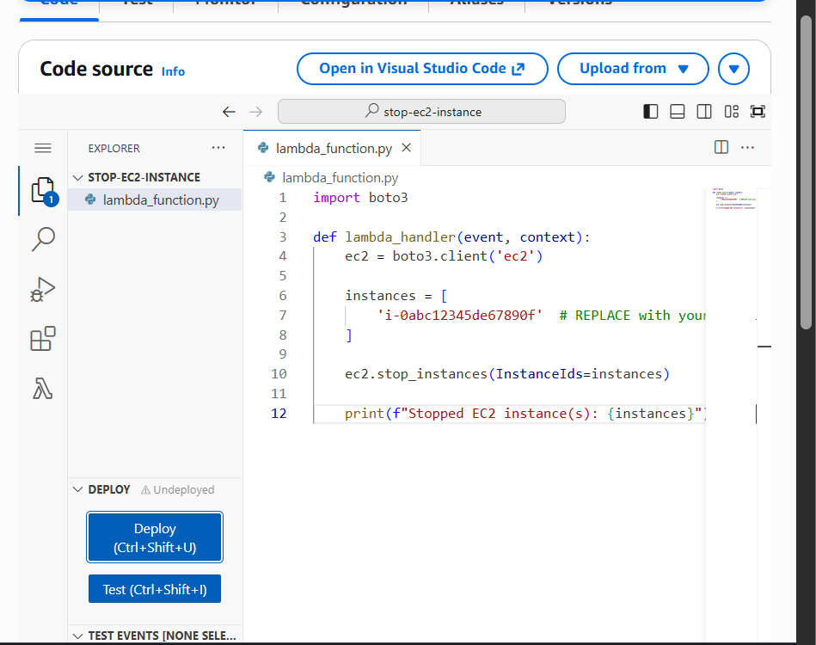
What this code does (simple English)
- Connects to EC2 service
- Tells AWS: stop this instance
- Writes a log message

🟢 Step 8: Click Deploy
✅ This saves your code
✅ Lambda is now ready to run
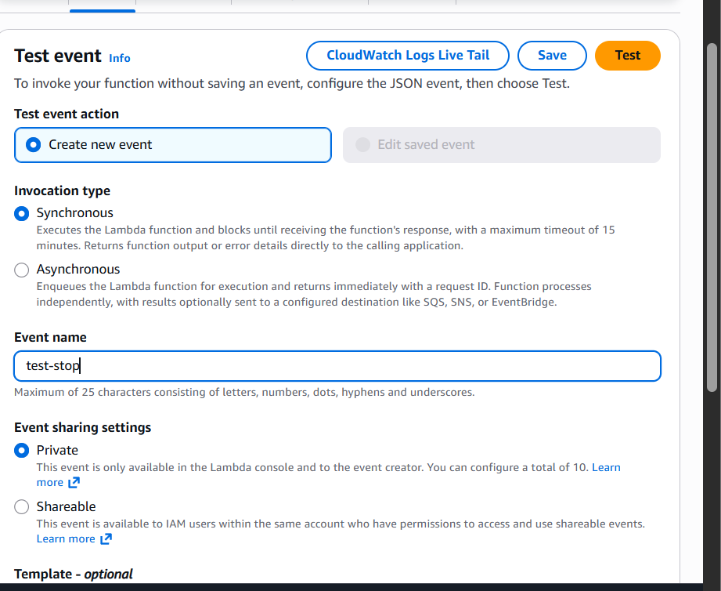

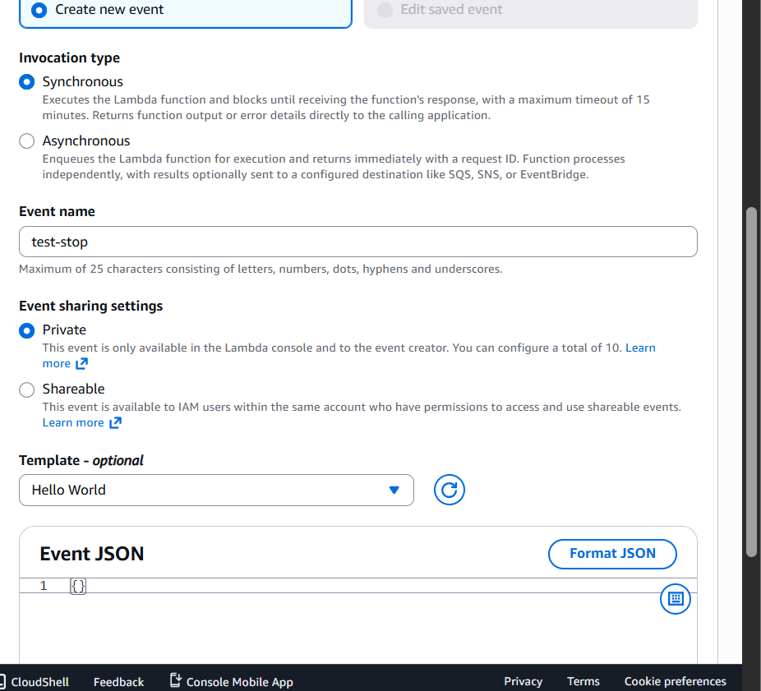
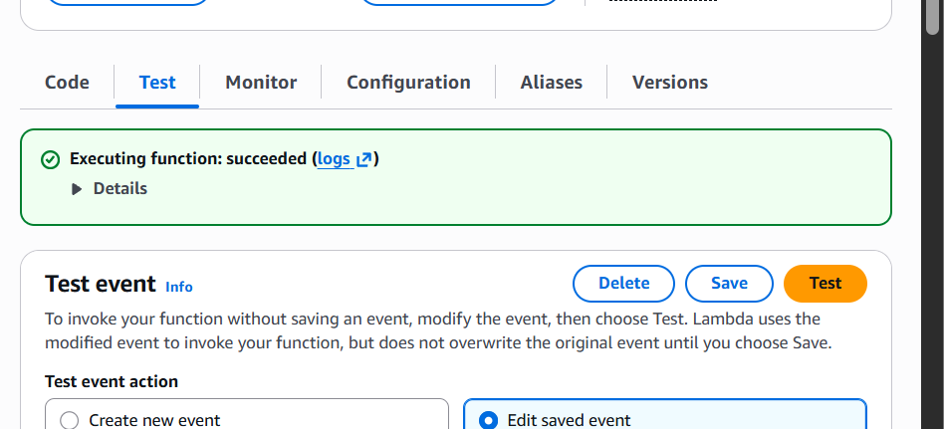
EC2 confirmation
Go to EC2 → Instances
You should see the instance state as:
Stopped
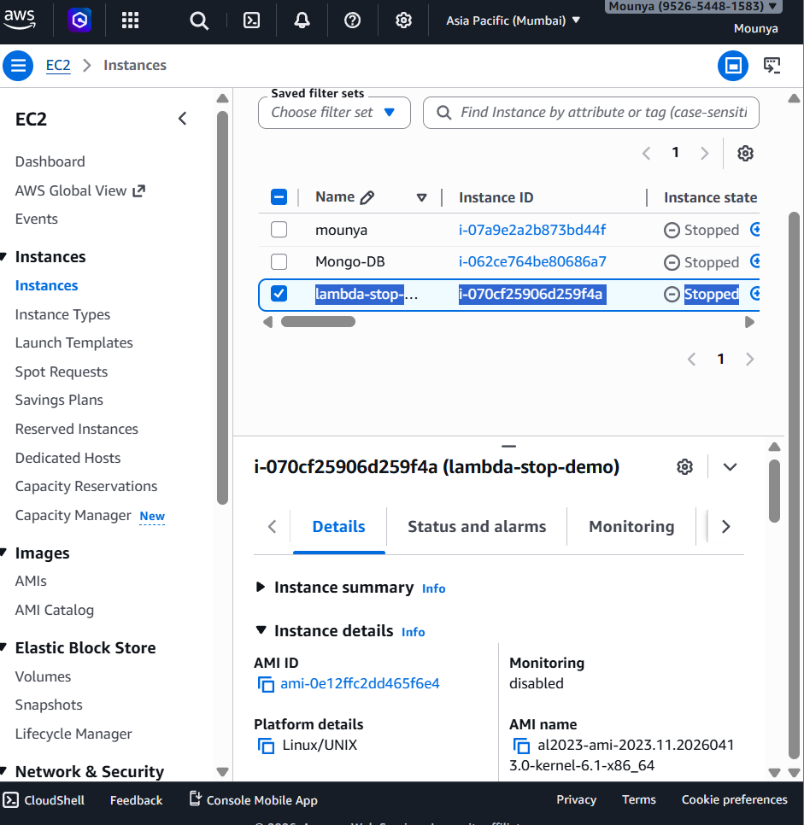

CloudWatch Logs confirmation
Go to Lambda → Monitor → View logs in CloudWatch, and open the latest log stream.

